5kW 2000 rpm PMSM Motor
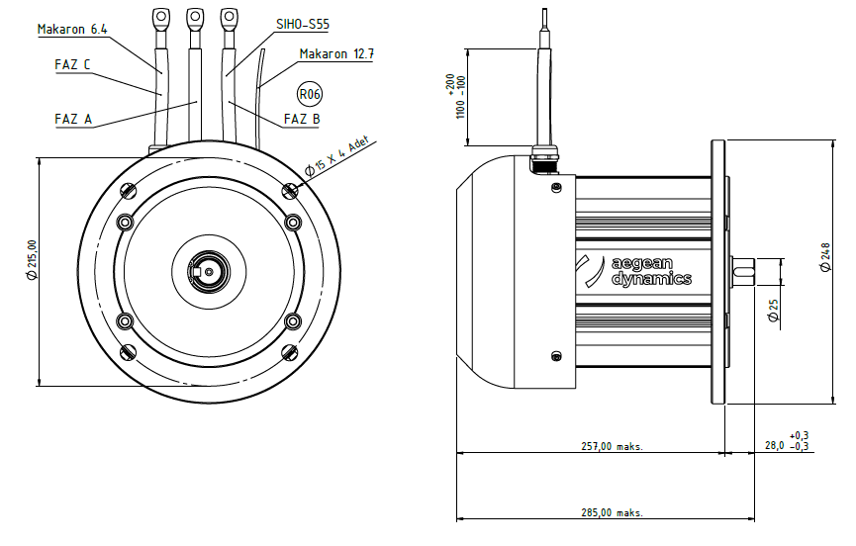
Basic Motor Parameters
Rated Power | W | 5000
Rated Speed | rpm | 2036
Rated Torque | Nm | 24
Rated Current | A | 115
Rated Voltage | V | 48
No-Load Speed | rpm | 2100
Max. Efficiency | % | 92
Electrical Parameters
Number of Phases |  | 3
Number of Poles |  | 6
Torque Constant (KT) | Nm/A | 0.20
Back EMF Constant (KE) | Vs/rad | 0.19
Terminal Resistance Phase to Phase (±%10) | mΩ | 11.92
Terminal Inductance Phase to Phase (±%30) | mH | 0.103
Thermal Data
Ambient Temperature | °C | -40...+85
Max. Winding Temperature | °C | +155
Physical Parameters
Outer Diameter | mm | 214
Shaft Diameter | mm | 25
Max. Lenght | mm | 285
Weight | gr | ~20000
Motor Connection
U | SIHO-S55 CABLE
V | SIHO-S55 CABLE
W | SIHO-S55 CABLE
Sensor Connection
N/A | N/A
Connector Articles
Power | N/A
Signal | N/A

